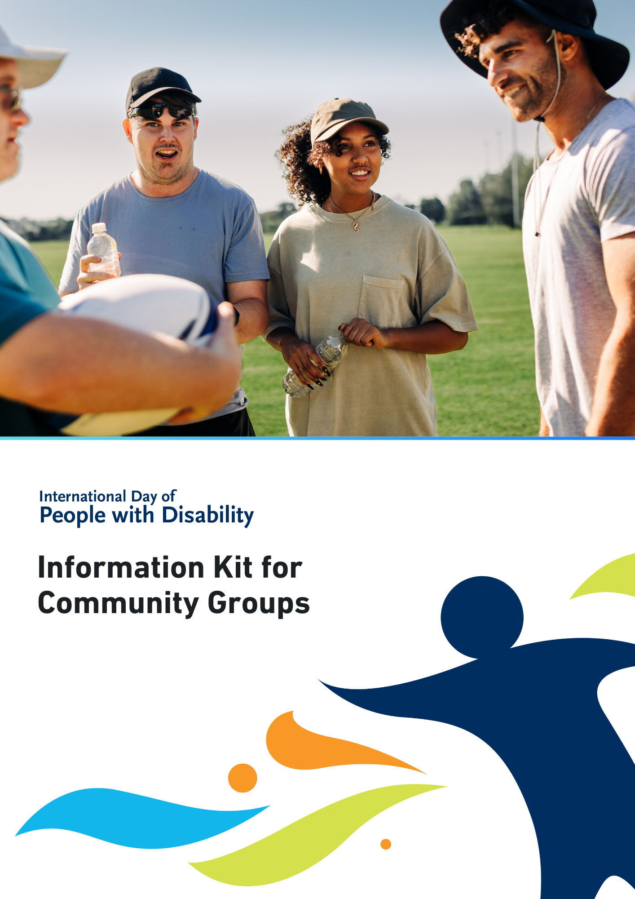

International Day of People with Disability (IDPwD) is a United Nations (UN) day, observed each year on 3 December. In Australia, it is a day to promote awareness, understanding and acceptance of the 5.5 million people with disability in the country.

A key part of IDPwD each year are the events and activities that schools, workplaces and community groups hold to mark the day.

Community groups play a vital role in creating a more inclusive and diverse community in Australia. This information kit has been developed to help community groups get involved. This includes local sports clubs, neighbourhood associations and volunteer groups.

Did you know?
- There are 5.5 million people with disability in Australia – that’s 1 in 5 people
- 15% of people in Australia aged 0-64 years have disability
- 52% of people in Australia aged 65 years and over have disability
- 7.9% of all Australians have a profound or severe disability
- 9.9% or 1 in 10 people with disability in Australia have experienced discrimination.

For more information about disability statistics in Australia, please visit the Australian Bureau of Statistics website.

IDPwD theme
Each year, the United Nations announces a theme for IDPwD. The theme assists in breaking down barriers and promoting diversity and inclusion.

The 2025 theme is:

Fostering disability-inclusive societies for advancing social progress.

The theme means we all need to work together to make society fairer and respect the rights of people with disability.

You can access an Easy Read version and learn more about the theme on the About IDPwD webpage.

You can use the official theme in your own IDPwD activity or event. You can also develop your own theme around the topics of disability, diversity and inclusion. There are some links on our Inclusion resources webpage to help get you started.

You can learn more about the theme on the About IDPwD webpage.

Ways your community can get involved
There are many ways your community can recognise IDPwD on 3 December and all year round. Your involvement can be big or small. We encourage you to get creative and mark IDPwD in your own unique way.

Host your own IDPwD event or activity
Holding events or activities are a great way to observe IDPwD and start inclusive conversations in your community.
We encourage you to register your community event, so we know about all the events happening across Australia. You can keep your event private or register as a public event and be featured on our community event calendar. To find out more, visit the Event Registrations page on the IDPwD website.
Here are some ideas to get you started.

Learn about disability inclusion together
- Taking time to learn about disability inclusion is a simple but impactful way to connect with all members of your community.
- Check out our Inclusion Resources page for useful links like disability language and etiquette, and ways to host inclusive events and meetings.
- You can also encourage your community group to take part in disability awareness training together.

Film screening
- Host a screening of short films or videos that feature people with disability or disability themes.
- Check out previous IDPwD Ambassador videos to learn about their lived experience.
- Visit the Focus on Ability Short Film Festival website to explore a diverse selection of short films. If you’d like to showcase their films at your event, you can send a request to admin@focusonability.com

Volunteering
- Get to know a local organisation that provides services and supports for people with disability and spend time volunteering with them.

Community get together
- Host a morning tea or sausage sizzle for your community group to recognise IDPwD.
- Consider inviting a person with disability or a disability advocate from your local community to speak about their experiences.

Community awards
- Acknowledge the people in your community who are championing disability inclusion.
- This could include recognising the accomplishments of individuals, sporting clubs or local businesses who are leading the way in accessibility and inclusive practices.
- You can use the editable IDPwD Certificate or create your own template using the IDPwD logo and branding.

Decorate your community
- Raise awareness of IDPwD by putting up posters and decorations in your local sports club, community hall or public notice boards.
- You can create your own IDPwD designs or use the printable resources on the IDPwD website.
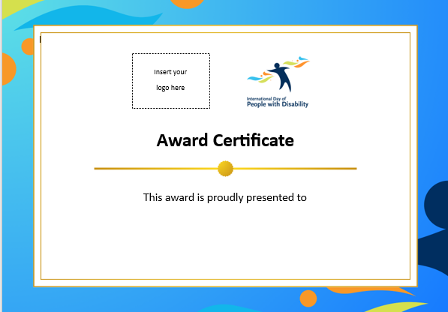
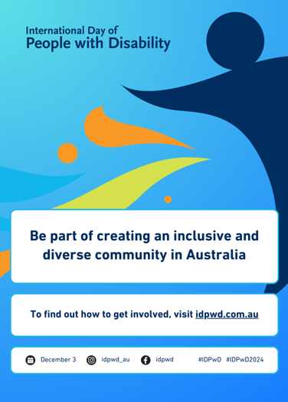

Join the conversation
If you can’t hold or attend an event, you can still get involved in IDPwD and help raise awareness in your community. Here are some ideas:
- Get your community together and support other IDPwD events in your local area or online. Check out our community event calendar for events happening near you.
- Post messages on your local community groups about IDPwD. Check out our online promotion kit for ideas to get you started.
- Learn more about IDPwD by checking out our fact sheets, which are available in 12 languages other than English, Auslan and Easy Read.
- Promote IDPwD in your online meetings and emails using our virtual meeting backgrounds and signature blocks.
- Follow or tag IDPwD on Facebook (@idpwd) and Instagram (@idpwd_au) to help spread stories about people with disability and be part of IDPwD all year round.
- Publish an article or acknowledgement in your community newsletter about IDPwD (see template below).

International Day of People with Disability with [community group]
International Day of People with Disability (IDPwD) is a United Nations day observed on 3 December each year to increase public awareness, understanding and acceptance of people with disability.
There are 5.5 million people with disability in Australia – that’s 1 in 5 people. By acknowledging this important day, we can take action and contribute to positive change in our community.
We play a key role in ensuring people with disability can participate in all aspects of community life.
This year [community group] will acknowledge IDPwD by [insert details of your event or activity].
We encourage everyone to get involved this IDPwD. Together, we can challenge perceptions about disability. We can also help remove barriers, and promote inclusive and respectful attitudes and behaviors in our community.
For more information, go to [your website address] or contact [your phone number/email address]. You can also visit our [Facebook page] for updates. For more information about IDPwD, visit idpwd.com.au

More information
Visit idpwd.com.au to find out more and access stories, videos and resources.
If you have any questions, you can:
- email us at idpwd@health.gov.au
- call us on 1800 440 385, 9am to 5pm Monday to Friday AEST/AEDT.
TTY (Speak and Read) users can phone 1800 555 677 and ask to be connected to IDPwD at 1800 440 385.

Source: Disability, Ageing and Carers, Australia survey 2022, Australian Bureau of Statistics www.abs.gov.au/disability

