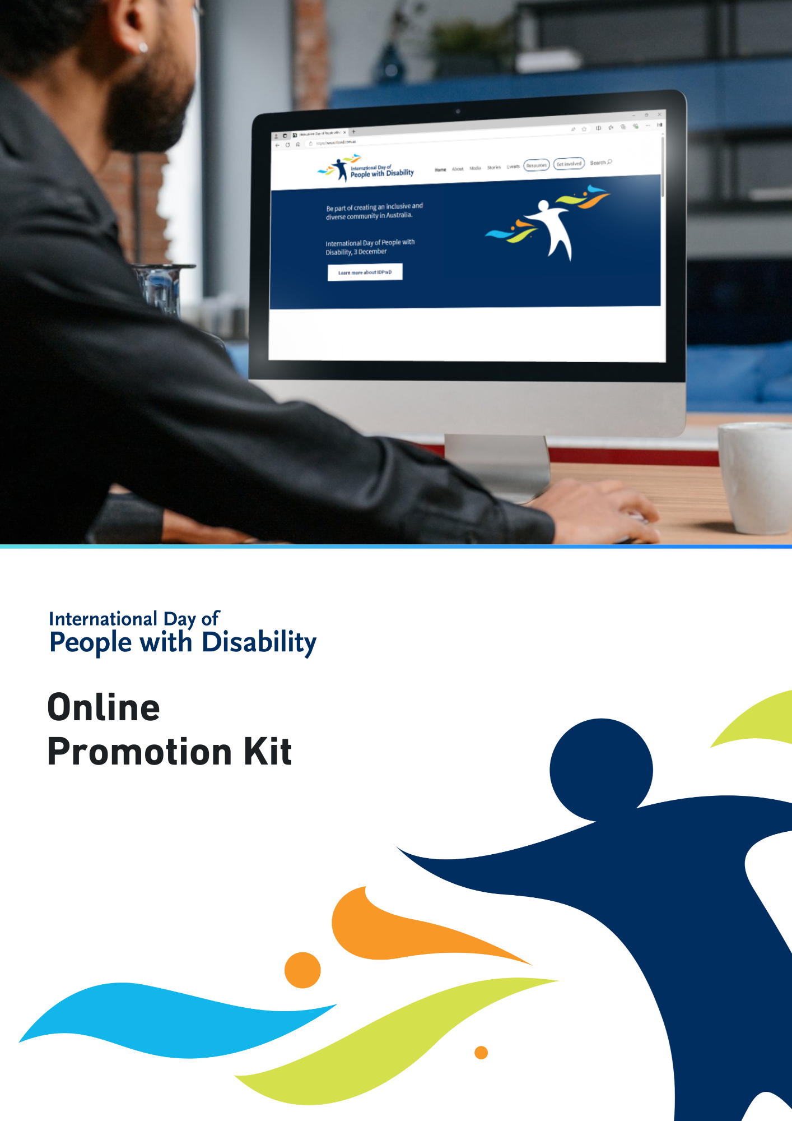

International Day of People with Disability (IDPwD) is a United Nations day, observed each year on 3 December. In Australia, it is a day to promote awareness, understanding and acceptance of the 5.5 million people with disability in the country.
Using online channels is one of the many ways you can raise awareness of IDPwD and promote messages of disability inclusion. We have developed this kit to give you some tools to promote your IDPwD events and activities online.
All assets referenced in this document are free to download and can be found on the IDPwD website. If you are planning your own event or activity for IDPwD, you can also check out our event information kits on the IDPwD website.

Did you know?
- There are 5.5 million people with disability in Australia – that’s 1 in 5 people
- 15% of people in Australia aged 0-64 years have disability
- 52% of people in Australia aged 65 years and over have disability
- 7.9% of all Australians have a profound or severe disability
- 9.9% or 1 in 10 people with disability in Australia have experienced discrimination.
For more information about disability statistics in Australia, please visit the Australian Bureau of Statistics website.

IDPwD theme
Each year, the United Nations announces a theme for IDPwD. The theme assists in breaking down barriers and promoting diversity and inclusion.

The 2025 theme is:

Fostering disability-inclusive societies for advancing social progress.

The theme means we all need to work together to make society fairer and respect the rights of people with disability.

You can access an Easy Read version and learn more about the theme on the About IDPwD webpage.

You can use the official theme in your own IDPwD activity or event. You can also develop your own theme around the topics of disability, diversity and inclusion. There are some links on our Inclusion resources webpage to help get you started.

You can learn more about the theme on the About IDPwD webpage.

Social media
We have developed some suggested social media posts below for you to post or adapt to suit your audience.
We’d love to see what you are doing for IDPwD so please tag us on Facebook (@idpwd) and Instagram (@idpwd_au). You can also use the hashtags #IDPwD and #IDPwD2025.
Post #1 – What is IDPwD?
International Day of People with Disability (IDPwD) is held on 3 December each year.
It is a day to raise community awareness, understanding and acceptance of the 5.5 million people with disability in Australia.
Be part of creating an inclusive and diverse community. Learn more at idpwd.com.au
Post #2 – To me, IDPwD means…
To me, International Day of People with Disability (IDPwD) means [add details about what IDPwD means to you].
Join me in the conversation to break down barriers and encourage a more diverse and inclusive community in Australia.
Learn more at idpwd.com.au
#IDPwD #IDPwD2025
Post #3 – Recognising IDPwD on 3 December
Today is International Day of People with Disability (IDPwD).
I am supporting IDPwD and taking action to be more inclusive by [add details about how you are taking part].
Learn more at idpwd.com.au
#IDPwD #IDPwD2025

Images
We have developed a range of images you can use to promote IDPwD on social media. They can be downloaded for free on the IDPwD social media webpage.
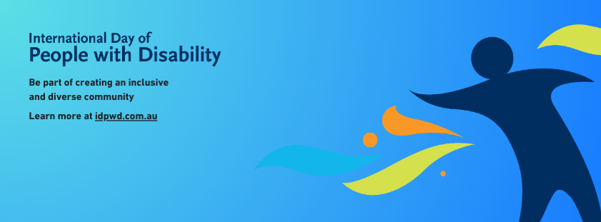
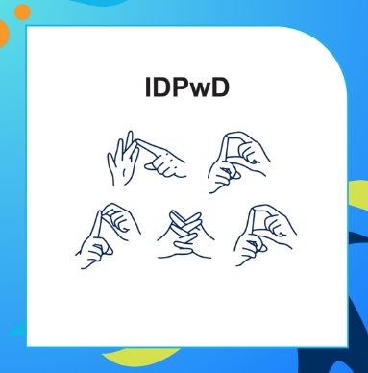

Writing alternative text
Alternative text (alt text) explains information in images for screen reader users, as well as people who are blind or have low vision. We encourage you to include alt text for all images you post on social media so that your content is accessible.
Alt text does not need to be a highly detailed description of an image. It only needs to account for the relevant information or context that would be missed without the visual cue.

Digital assets
We have developed digital assets that you can use to promote IDPwD and spread messages of disability inclusion online. This includes email signature blocks and virtual meeting backgrounds. Check them out on the IDPwD promotional assets webpage.
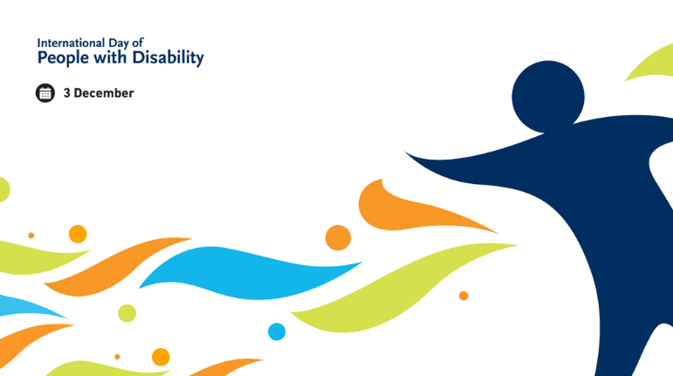
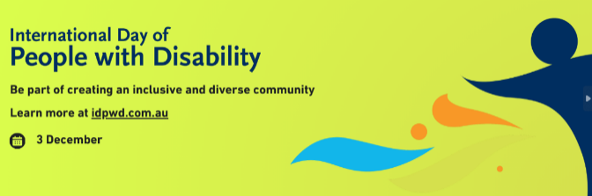

Create your own materials
If you are feeling a bit more creative, you can use the IDPwD brand to develop your own promotional materials.
The IDPwD Logo Guidelines provide information about using our logo and colour palette. They also answer some frequently asked questions.

Editable templates
We have also developed editable promotional materials that you can customise with your own logo, event details or photos. Find out more on the IDPwD promotional assets webpage.
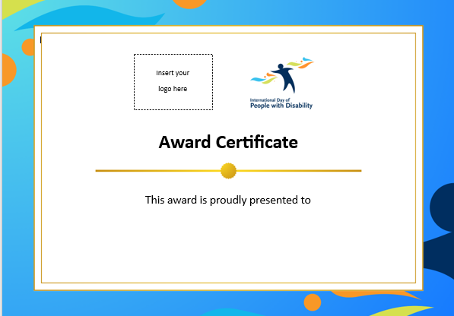
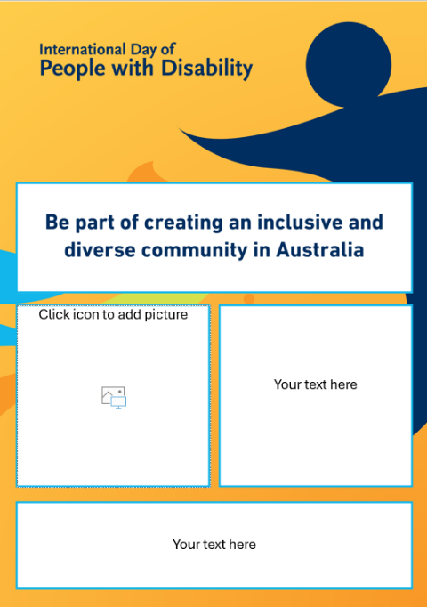

More information
Visit idpwd.com.au to find out more and access stories, videos and resources.
If you have any questions, you can:
- email us at idpwd@health.gov.au
- call us on 1800 440 385 9am to 5pm Monday to Friday AEST/AEDT.
TTY (Speak and Read) users can phone 1800 555 677 and ask to be connected to IDPwD at 1800 440 385.

Source: Disability, Ageing and Carers, Australia survey 2022, Australian Bureau of Statistics www.abs.gov.au/disability

