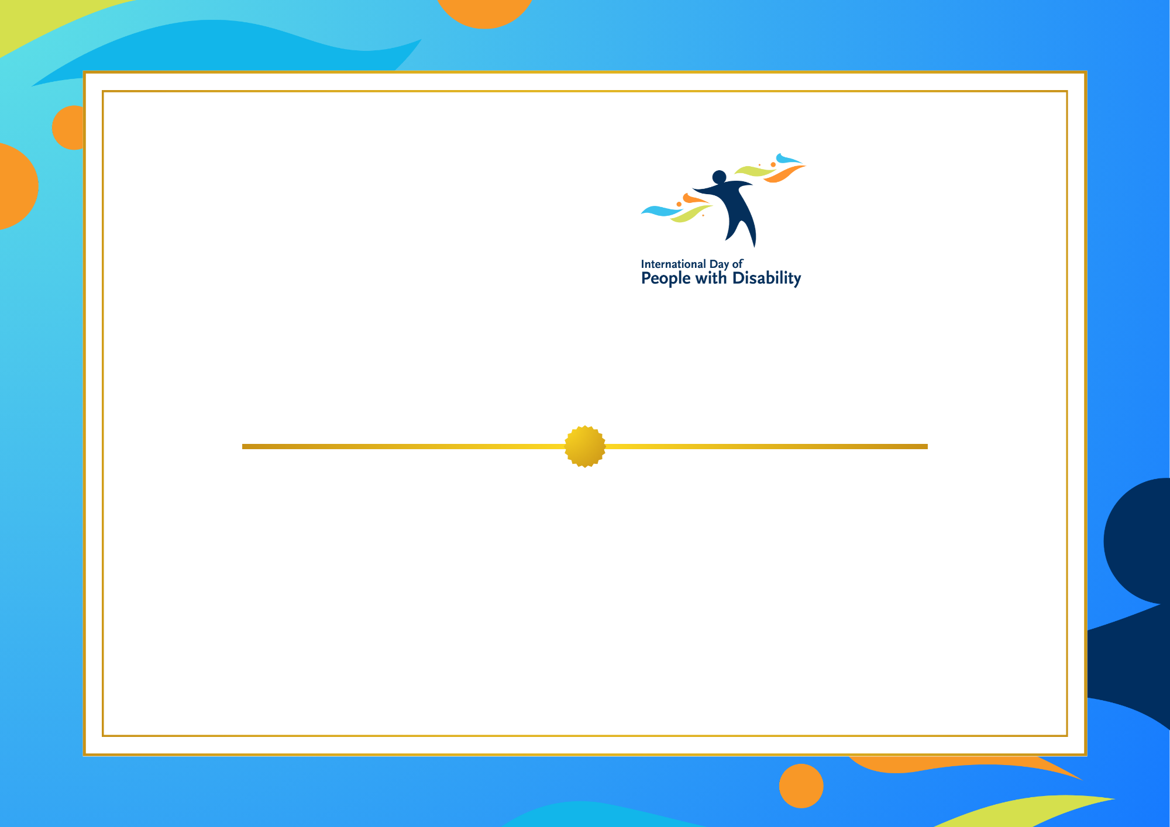
It’s our pleasure to invite (name)
Date: Time:
Location:

You’re Invited

Insert your
logo here

Instructions:

To include your logo:
- Select Insert at the top left of the navigation bar.
- Select Pictures at the top left of the navigation bar.
- Select This Device… from the dropdown options.
- Navigate to where your logo is saved, select the file and click open.
- Position your logo to sit beneath the IDPwD logo.
- Delete the placeholder text box by selecting it and hitting Delete on your keyboard.

To delete this page:
- When your design is complete, select all of the text on this page by left-clicking and dragging your mouse.
- Select Delete on your keyboard.
- Select backspace on your keyboard until this page is removed.

To save and export your document as a PDF:
- Select File at the top left of the navigation bar.
- Select Save. Save your file to where you would like it located.
- Again, select File at the top left of the navigation bar.
- Select Export from the options that appear.
- Select Create PDF/XPS.
- Save the PDF where you would like it located.

