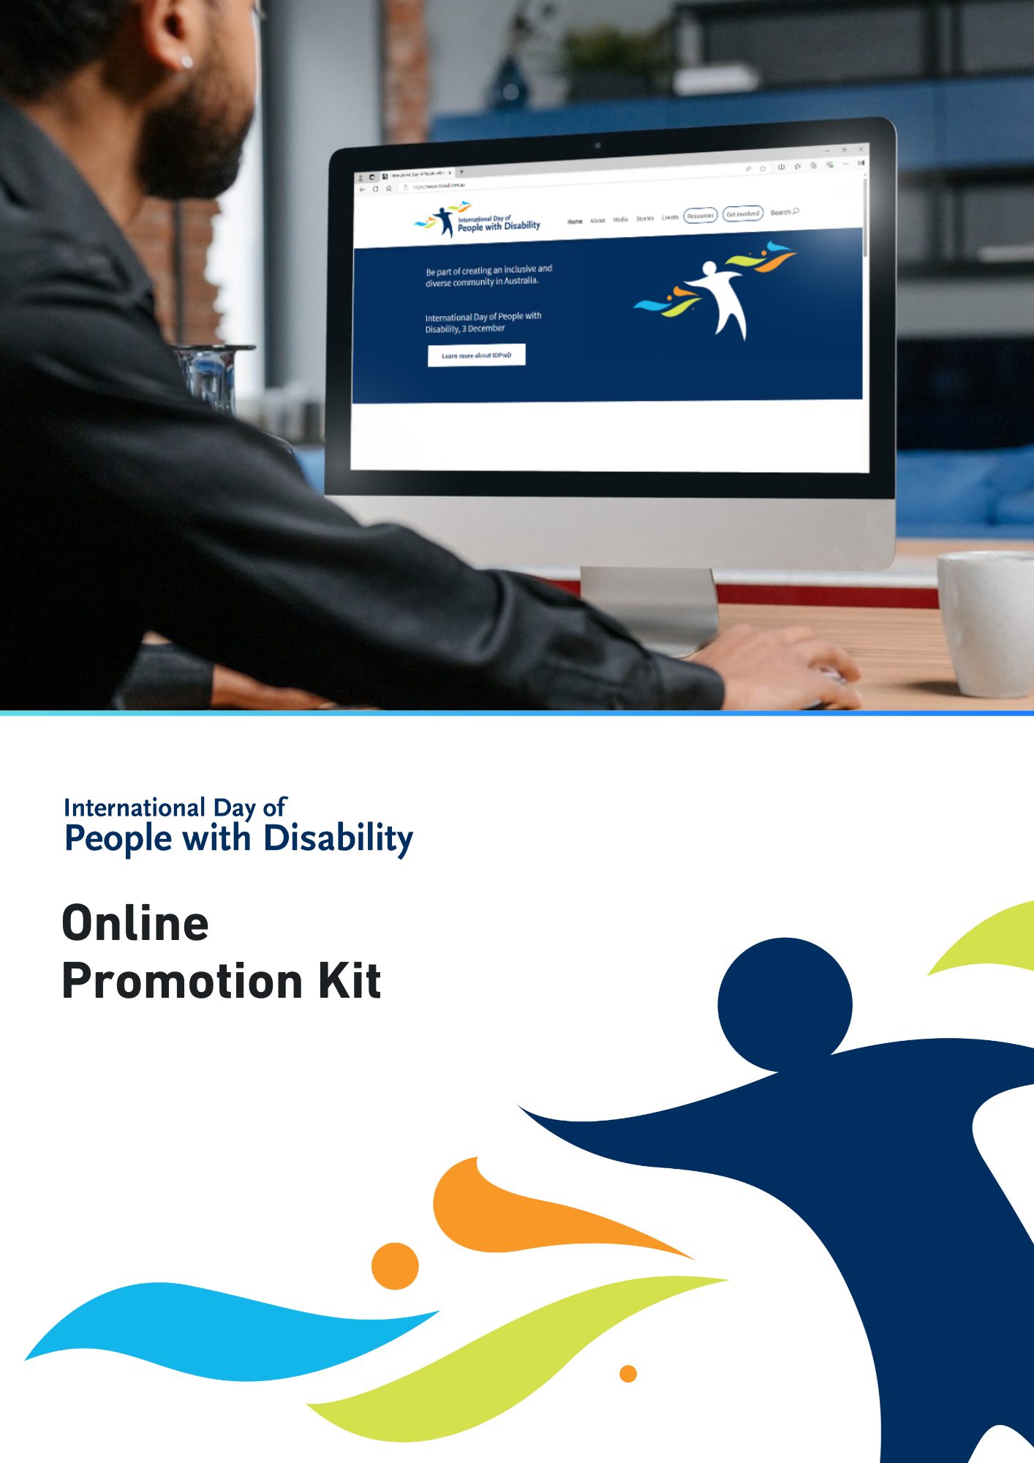

International Day of People with Disability
International Day of People with Disability (IDPwD) is a United Nations day, observed each year on
3 December. In Australia, it is a day to promote awareness, understanding and acceptance of the 5.5 million people with disability in the country.
Using online channels is one of the many ways you can raise awareness of IDPwD and promote messages of disability inclusion. We have developed this kit to give you some tools to promote your IDPwD events and activities online.
All the resources referenced in this document are free to download on the IDPwD website.

Did you know?
- There are 5.5 million people with disability in Australia – that’s 1 in 5 people
- 15% of people in Australia aged 0-64 years have disability
- 52% of people in Australia aged 65 years and over have disability
- 7.9% of all Australians have a profound or severe disability
- 9.9% or 1 in 10 people with disability in Australia have experienced discrimination.
For more information about disability statistics in Australia, visit the Australian Bureau of Statistics website.

IDPwD theme
Each year, the United Nations announces a theme for IDPwD in late October or early November.
We do not know what they will announce. The theme usually focuses on how society can strive for
inclusion by removing barriers for people with disability.
We will update this information kit as soon as the UN announces the 2026 theme. We will also publish an Easy Read version of the theme on our website.
You can use the official theme in your own IDPwD activity or event. You can also develop your own
theme around the topics of disability, diversity and inclusion. There are some links on our Inclusion Resources page to help get you started.
You can learn more about the theme on the IDPwD website.

Events
If you are planning your own event or activity for IDPwD, check out our event information kits for schools, workplaces and communities on the IDPwD website.
We encourage you to register your community event, so we know about all the events happening across Australia. You can keep your event private or register as a public event and be featured on our community event calendar.
To find out more, visit the Event Registrations page on our website.

Social media
We have developed some suggested social media posts below for you to post or adapt to suit your audience.
We’d love to see what you are doing for IDPwD so please tag us on Facebook (@idpwd) and Instagram (@idpwd_au). You can also use the hashtags #IDPwD and #IDPwD2026.

Post #1 – What is IDPwD?
International Day of People with Disability (IDPwD) is held on 3 December each year.
It is a day to raise community awareness, understanding and acceptance of the 5.5 million people
with disability in Australia.
Be part of creating an inclusive and diverse community.
Learn more at www.idpwd.gov.au.

Post #2 – To me, IDPwD means…
To me, International Day of People with Disability (IDPwD) means [add details about what IDPwD
means to you].
Join me in the conversation to break down barriers and encourage a more diverse and inclusive
community in Australia.
Learn more at www.idpwd.gov.au.
#IDPwD #IDPwD2026

Post #3 – Recognising IDPwD on 3 December
Today is International Day of People with Disability (IDPwD).
I am supporting IDPwD and taking action to be more inclusive by [add details about how you are taking part].
Learn more at www.idpwd.gov.au.
#IDPwD #IDPwD2026

Images
We have developed a range of social media images, such as tiles and banners, you can use to promote IDPwD on your social media channels that can be downloaded for free on our website.
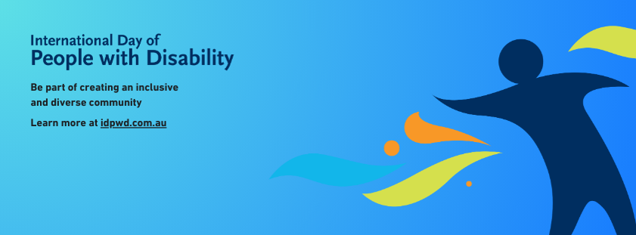
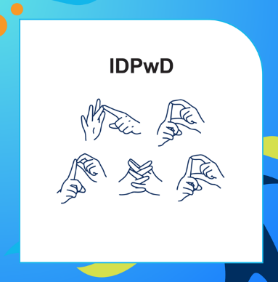

Writing alternative text
Alternative text (alt text) explains information in images for screen reader users, as well as people who are blind or have low vision. We encourage you to include alt text for all images you post on social media so that your content is accessible.
Alt text does not need to be a highly detailed description of an image. It only needs to account for the relevant information or context that would be missed without the visual cue.

Digital assets
We have developed digital assets that you can use to promote IDPwD and spread messages of disability inclusion online. This includes email signature blocks and virtual meeting backgrounds.
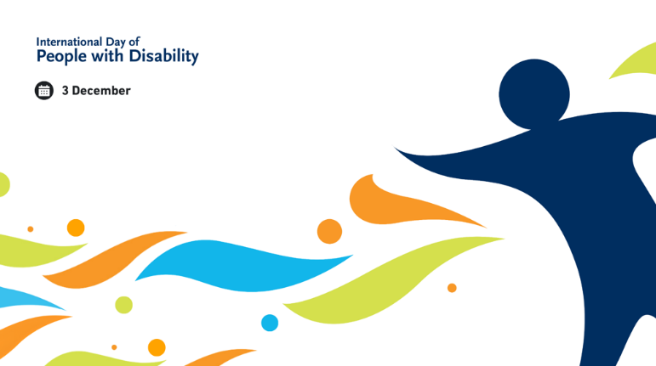
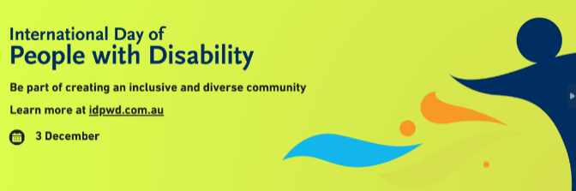
Check them out on the IDPwD digital assets page.

Create your own materials
If you are feeling a bit more creative, you can use the IDPwD brand to develop your own promotional materials.
The IDPwD Logo Guidelines provide information about using our logo and colour palette. They also answer some frequently asked questions.

Editable templates
We have also developed editable promotional materials that you can customise with your own logo, event details or photos. Find out more on the IDPwD promotional assets page.
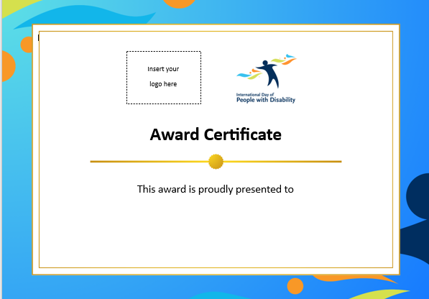
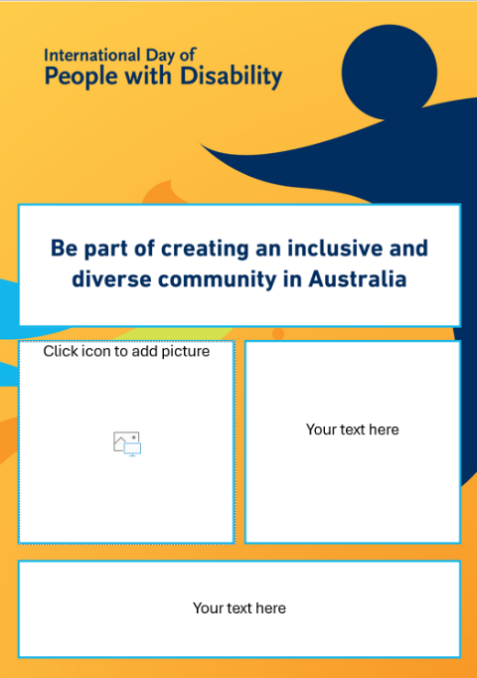

More information
Visit www.idpwd.gov.au to find out more and access stories, videos and resources.
If you have any questions, you can:
- email us at idpwd@health.gov.au
- contact us at www.idpwd.gov.au/contact-us.

Source: Disability, Ageing and Carers, Australia survey 2022, Australian Bureau of Statistics www.abs.gov.au/disability

